**1.INTRODUCTION**

**1.1 overview**

This page describes and payment book application is designed to maintain customer, payments and their purchases. A retailer will be an admin of the application and each customer of the retailer’s shop will be the user. Customers can create their account in the payment book app by reading and agree to the terms and conditions of the shop.

**1.2 purpose**

The purpose of digital payment books are to reduce the costs and risks of handling cash, increase the ease of conducting online payment books, and increase transparency among monetary transactions among people

**2.LITERATURE SURVEY**

**2.1 Existing problem**

Once a user created their account they can login to their account by using their own credential, user will be able to see their purchase history ,pending payments and also if the user is having any doubt or complaints they can contact the retailer by using contact us service.

**2.2 proposed solution**

Admin will maintain data about purchases made by the customers & can see payment details and pending payment of the customers. Admin will send alerts to the customers if there is any due for payment or payment is pending for a long time.

**3.THEORITICAL ANALYSIS**

**3.1 Flow chart**

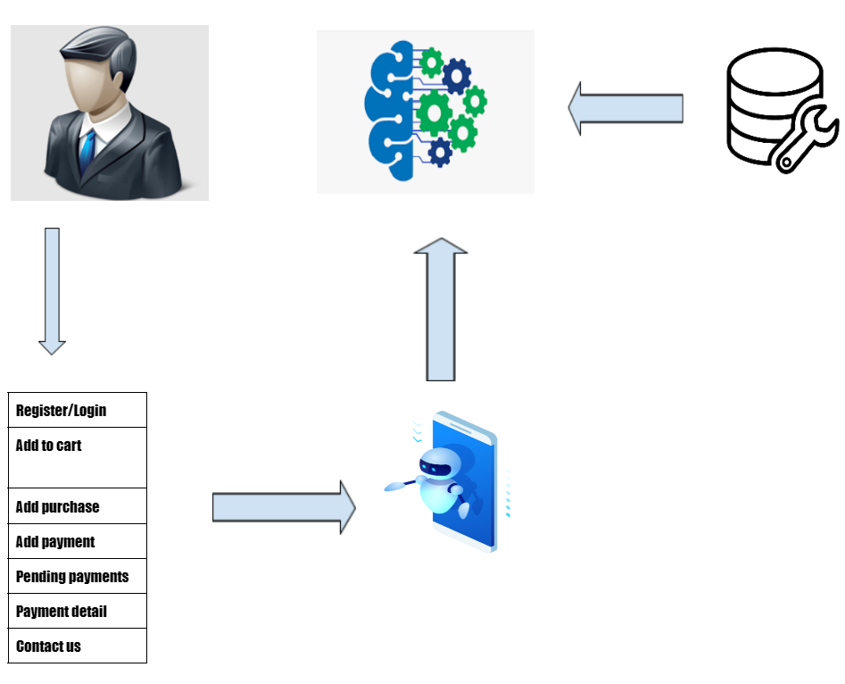

**3.2 Hardware/software designing**

* Flask
* IBM DB2
* Docker
* OpenShift Dedicate

**4.EXPERIMENTAL INVESTIGATIONS**

* All the supermarkets,shops can use this Digital payment book for  keeping their customer data.
* Customers can also interact more with the Admin by the contact us

option so by this the Admin can improve their business well .

* In future the digital payments book are going to be a must and so the change in the habits of the people to accept the digital payment book is also must.

**5.RESULT**

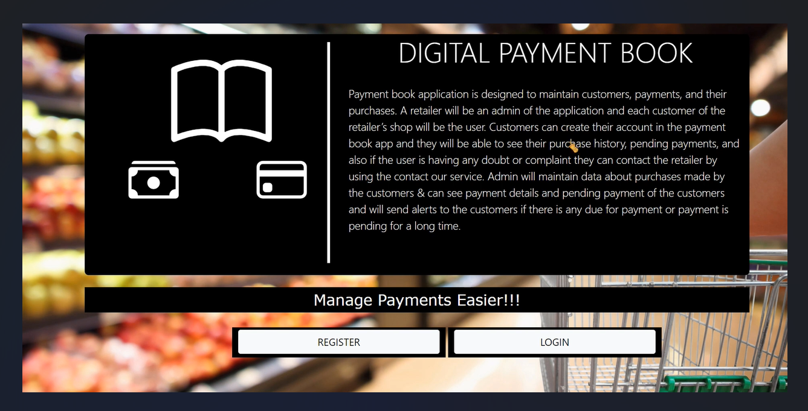

6. **Advantages**

Carrying cash at all times can be a risky decision. This is why senior citizens are common targets of small thefts or robberies. One of the main advantages of digital payments is that they are much more secure thanregular cash transactions ,as they require proper verifications and authentication.

**Disadvantages**

* Not traceable : The digital cash uses the internet , which makes traceable difficulty .Hence , the system provides anonymity
* Illiterate people cannot access the digital payment .

**7. Applications**

Digital payment methods are often easy to make, more convenient and provide customers the flexibility to make payments from anywhere and at anytime. These are a good alternative to traditional methods of payment and speed up transaction cycles. Post demonetization, people slowly started embracing digital payments and even small time merchants and shop owners started accepting payments through the digital mode.

**8.Conclusion**

One of the most significant advantages of digital payment is the seamless experience they provide to customers. Reduced dependency on cash, fast transfer speed, and the ease of transacting make online payment a preferred option.

**9.Future scope**

Digital payments will increase employement , reduce risks related to cash like corruption, robbery, and carrying large amount of cash , helping people to transfer the money with security at high speed.